1. BandWidth Test

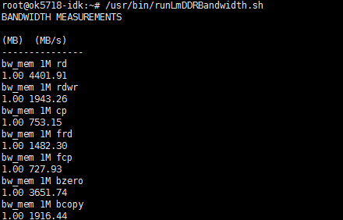

2. Memory Latency Test

HDMI->ARM->Communication Latency

